Job Information |  | Technical Data Sheet | 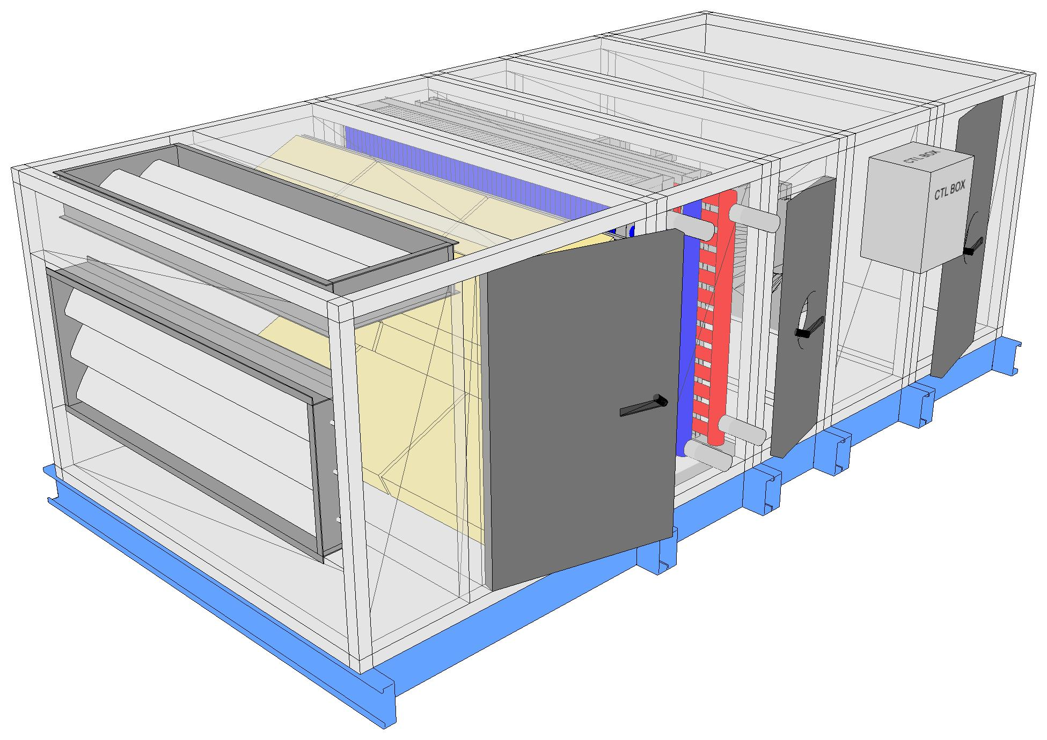
Job Name | 1095040 - NDSU Engineering Building 2024
Date | July 28 2025
Submitted By | JF
Software Version | 13.63
Unit Tag | AHU-E1

Unit Overview
Model Number | Supply
Model Number | Air Volume  cfm | Static Pressure |  |  | External Dimensions
Model Number | Air Volume  cfm | External  inWc | Total  inWc | Height  in | Width  in | Length  in
CAH016GDCM | 7770 | 1.50 | 3.23 | 48* | 72* | 148
*Not including base rails, coil connectors, drain connectors and control boxes.

Unit
Model Number: | CAH016GDCM
Approval: | ETL Listed / ETL Listed to Canadian Safety Standards (ETL Label / ETLc Label)
Outer Panel: | 24 gauge G90 Galvanized Steel (unpainted)
Liner: | 24 gauge Galvanized Steel (unless noted per section)
Insulation: | R-13 Injected Foam
Sound Baffles: | Included in Fan, Plenum, Access and Manual section (unless noted per section)
Unit Configuration: | Inline horizontal | Drive (Handling) Location: | Right
Base: | 6" formed channel | Wall Thickness: | 2 in
Altitude: | 0 ft | Parts Warranty: | Standard One Year

Mixing Box |  |  |  |  | Component: 1 |  |  |  |  | Length: 52 in |  |  |  |  | Shipping Section: 1
Portion | Damper |  |  |  |  |  |  |  |  |  |  |  |  |  | Blade Action |  |  | Rated CFM |  | Air Pressure Drop |  |  | Quantity
Portion | Size (length x width) |  |  |  |  |  | Location |  |  | Type | Actuation
Portion | Overall |  |  | Opening
Outside Air | 24 in x 68 in |  |  | 20 in x 58 in |  | End |  |  | UltraSeal Low Leak | NA | Parallel |  |  | 7770 cfm |  | 0.09 insWg |  |  | 1
Return Air | 22 in x 68 in |  |  | 18 in x 58 in |  | Top |  |  | UltraSeal Low Leak | NA | Parallel |  |  | 7770 cfm |  |  |  |  | 1
Filter Data
Type |  |  | Efficiency |  |  |  | Face Velocity |  |  | Face Area |  |  | Air Volume |  |  |  | Filter Loading
Pre Pleat |  |  | MERV 13 |  |  |  | 241 ft/min |  |  | 32.2 ft² |  |  | 7770 cfm |  |  |  | Side
Air Pressure Drop |  |  |  |  |  |  |  |  |  |  |  |  | Number of Filters |  | Height |  |  | Width |  |  | Depth
Clean Air |  | Mean Air |  |  | Dirty Air |  |  | User Spec
0.08 inWc |  | 0.54 inWc |  |  | 1.00 inWc |  |  | N/A |  | 6 |  | 24 in |  |  | 24 in |  |  | 4 in
 |  |  |  |  |  |  |  |  |  | 3 |  | 24 in |  |  | 20 in |  |  | 4 in
Door
Location |  |  |  |  | Width |  |  |  |  | Opening |  |  |  |  | Light
Drive side |  |  |  |  | 28 in |  |  |  |  | Outward |  |  |  |  | LED marine light kit and switch only
Special Options
Sound Baffle |  |  |  |  |  |  |  |  |  | Filter Gauge
(As casing details) |  |  |  |  |  |  |  |  |  | Magnehelic 0-2"

Combination Coil |  |  |  |  | Component: 2 |  |  |  |  |  | Length: 24 in |  |  |  |  |  | Shipping Section: 2
Chilled Water Coil
Coil Model |  | Total Capacity |  |  | Sensible Capacity |  |  | Number of Coils |  |  | Number of Rows |  |  | Fins per Inch |  |  | Tube Diameter |  |  | Tube Spacing  (Face x Row)
5WL1106B |  | 312490 Btu/hr |  |  | 217388 Btu/hr |  |  | 1 |  |  | 6 |  |  | 11 |  |  | 0.625 in |  |  | 1.50 in x 1.299 in
Air Volume | Air Temperature |  |  |  |  |  |  |  |  |  |  |  |  | Coil Air Pressure Drop |  | Finned Height |  | Finned Length |  |  | Face Area |  |  | Face Velocity
Air Volume | Entering |  |  |  |  |  |  | Leaving
Air Volume | Dry Bulb |  |  | Wet Bulb |  |  | Dry Bulb |  | Wet Bulb
7770 cfm | 80.0 °F |  |  | 67.0 °F |  |  | 54.4 °F |  | 53.9 °F |  | 0.72 inWc |  | 39 in |  | 59 in |  |  | 15.98 ft² |  |  | 486 ft/min
Fluid |  |  |  |  |  |  | Flow Rate |  |  |  | Pressure Drop |  | Velocity |  |  |  | Volume |  |  | Weight
Entering |  |  | Leaving
42.0 °F |  |  | 57.1 °F |  |  | 46.10 gpm |  |  |  | 11.20 ftHd |  | 2.50 ft/s |  |  |  | 13.0 gal |  |  | 114.00 lb
Connection [Data Per Coil] |  |  |  |  |  |  |  |  |  |  |  |  |  | Glycol Type |  |  | Min. Fin Surface Temp. |  |  | Min. Tube Wall Surface Temp. |  |  | Fouling Factor
Type |  | Size |  |  | Location |  |  | Material
Threaded |  | 2.50 in |  |  | Drive side |  |  | Carbon steel |  |  | Ethylene (35%) |  |  | 42.0 °F |  |  | 42.0 °F |  |  | 0.000
Material |  |  |  |  |  |  |  |  |  |  |  |  |  |  | Drain Pan |  |  |  | Drain Side |  |  | Turbospiral
Fin |  |  | Tube |  |  | Header |  |  |  | Case
Aluminum .0075 in |  |  | Copper .020 in |  |  | Copper |  |  |  | Galv. steel |  | Stainless steel |  |  |  | Drive side |  |  | Yes
Component performance shown is based on the component air volume shown.
Static pressure shown is based on the component air volume shown.
AHRI 410 Certification
Coil is NOT certified by AHRI
Reheat Hot Water Coil
Coil Model |  |  | Total Capacity |  |  | Number of Coils |  |  |  | Number of Rows |  | Fins per Inch |  |  |  | Tube Diameter |  |  | Tube Spacing  (Face x Row)
5WH1002C |  |  | 435461 Btu/hr |  |  | 1 |  |  |  | 2 |  | 10 |  |  |  | 0.625 in |  |  | 1.50 in x 1.299 in
Air Volume |  | Air Temperature |  |  |  |  |  |  | Coil Air Pressure Drop |  |  | Finned Height |  |  | Finned Length |  |  | Face Area |  |  | Face Velocity
 |  | Entering |  |  | Leaving
 |  | Dry Bulb |  |  | Dry Bulb
7770 cfm |  | 40.0 °F |  |  | 91.3 °F |  |  | 0.33 inWc |  |  | 39 in |  |  | 56 in |  |  | 15.17 ft² |  |  | 512 ft/min
Fluid |  |  |  |  |  |  | Flow Rate |  |  |  | Pressure Drop |  | Velocity |  |  |  | Volume |  |  | Weight
Entering |  |  | Leaving
160.0 °F |  |  | 119.0 °F |  |  | 23.10 gpm |  |  |  | 4.00 ftHd |  | 1.90 ft/s |  |  |  | 5.0 gal |  |  | 47.00 lb
Connection [Data Per Coil] |  |  |  |  |  |  |  |  |  |  |  |  |  | Glycol Type |  |  | Min. Fin Surface Temp. |  |  | Min. Tube Wall Surface Temp. |  |  | Fouling Factor
Type |  | Size |  |  | Location |  |  | Material
Threaded |  | 2.50 in |  |  | Drive side |  |  | Carbon steel |  |  | Ethylene (35%) |  |  | 119.0 °F |  |  | 119.0 °F |  |  | 0.000
Material |  |  |  |  |  |  |  |  |  |  |  |  |  |  |  |  |  |  |  |  | Turbospiral
Fin |  |  |  | Tube |  |  |  |  | Header |  |  |  | Case
Aluminum .0075 in |  |  |  | Copper .020 in |  |  |  |  | Copper |  |  |  | Galv. steel |  |  |  |  | Yes
Component performance shown is based on the component air volume shown.
Static pressure shown is based on the component air volume shown.
AHRI 410 Certification
Coil is NOT certified by AHRI

Access Section |  | Component: 3 |  | Length: 18 in |  | Shipping Section: 3
Air Pressure Drop
0.00 inWc
Door
Location | Width |  | Opening |  | Window Type |  | Light
Drive side | 14 in |  | Outward |  | Round |  | LED marine light kit and switch only

Supply Fan Array |  |  |  |  |  | Component: 4 |  |  |  |  |  |  |  | Length: 24 in |  |  |  |  |  |  |  | Shipping Section: 4
Fan Performance
Air Volume* | Static Pressure |  |  |  |  |  |  |  |  | Fan Energy Index(FEI) |  | Total Input Power |  |  | Fan Shaft Power* |  | Speed |  |  |  |  |  | Redundancy(N-1) |  |  |  |  | Fan Circuit
Air Volume* | External |  | Total |  | Cabinet |  |  |  |  |  |  |  |  |  | Operating |  |  | Maximum |  |  |  |  |  |  | MOP |  | MCA
3885 cfm | 1.50 inWc |  | 3.23 inWc |  | 0.00 inWc |  |  | 1.36 |  | 5.1 kW |  |  | 3.08 BHP |  | 3222 rpm |  |  | 3300 rpm |  | 60.5 % |  |  |  |  | 30.0 A |  | 22.7 A
Fan Data
Fan Type |  | Blade Type / Class |  |  |  |  | Quantity of Fans |  |  |  |  | Wheel Diameter |  |  |  | Number of Blades |  |  |  |  | Discharge |  |  |  | Motor Location
ECM / 1x2 : 2 |  | Airfoil / N/A |  |  |  |  | 2 |  |  |  |  | 13.98 in |  |  |  | 5 |  |  |  |  | Axial |  |  |  | Behind Fan
Motor Data
Power* |  |  |  | Electrical Supply |  |  |  |  |  |  | Speed |  |  |  |  |  | Control Signal |  |  |  |  |  | Full Load Current*
4.4 HP |  |  |  | 200/60/3 V/Hz/Phase |  |  |  |  |  |  | 3230 rpm |  |  |  |  |  | 0-10V |  |  |  |  |  | 10.10 A
Fan Options
Isolator Type: |  |  |  |  |  | Rigid
Control Data
Selection Type: |  |  |  |  |  | Integrated Drive |  |  |  |  |  |  |  | Vendor: |  |  |  |  |  |  |  | Daikin Applied
Auxiliary Control: |  |  |  |  |  | Disconnect w/ motor starter |  |  |  |  |  |  |  | VFD Power: |  |  |  |  |  |  |  | 4.42 HP
Voltage: |  |  |  |  |  | 200 V |  |  |  |  |  |  |  | Disconnect Type: |  |  |  |  |  |  |  | Fused
Height x Width x Depth: |  |  |  |  |  | 15.75 in x 11.81 in x 10.76 in |  |  |  |  |  |  |  | Mounting: |  |  |  |  |  |  |  | Drive Side
Enclosure: |  |  |  |  |  | NEMA 3R
Control box: |  |  |  |  |  | No controls, unit mounted power box, drive side
Panel
Location |  |  |  |  |  |  |  |  | Width |  |  |  |  |  |  |  |  |  | Opening
Removable panels |  |  |  |  |  |  |  |  | - in |  |  |  |  |  |  |  |  |  | Outward
Notes
* after a unit label denotes the data per fan.
Due to multi-sourcing of ECM fans, motor nameplate electrical data values MOP, MCA and Full Load Current may be equal to or less than presented.
Due to multi-sourcing of ECM fans, motor nameplate Power may be greater than presented.

Plenum Section |  | Component: 5 |  |  | Length: 30 in |  |  | Shipping Section: 5
Opening Location |  |  | Opening Size |  |  |  | Air Pressure Drop
Top |  |  | 26.00" x 68.00" |  |  |  | 0.05 inWc
Door
Location | Width |  |  | Opening |  | Window Type |  |  | Light
Drive side | 18 in |  |  | Outward |  | Round |  |  | LED marine light kit and switch only
Special Options
Tread Plate Floor Liner |  |  |  |  | Sound Baffle
Tread plate installed |  |  |  |  | Sound baffle included

Unit Sound Power (dB)
Type | 63 Hz | 125 Hz | 250 Hz | 500 Hz | 1000 Hz | 2000 Hz | 4000 Hz | 8000 Hz
Radiated: | 67 | 58 | 68 | 53 | 53 | 45 | 46 | 51
Unit Discharge: | 75 | 60 | 78 | 66 | 67 | 65 | 63 | 63
Unit Return: | 67 | 58 | 68 | 57 | 54 | 54 | 50 | 52

Shipping Section Details
Section | Length  in | Weight  lb | Corner Weights (lb) |  |  |  |  |  |  | Center of Gravity (in)
Section | Length  in | Weight  lb | P1 | P2 | P3 | P4 | XX | YY | ZZ
1 | 52 | 602 | 144 | 144 | 157 | 157 | 27 | 36 | 27
2 | 24 | 1015 | 271 | 246 | 237 | 262 | 12 | 34 | 26
3 | 18 | 234 | 52 | 52 | 65 | 65 | 10 | 36 | 23
4 | 24 | 552 | 155 | 144 | 120 | 132 | 11 | 35 | 23
5 | 30 | 375 | 94 | 94 | 94 | 94 | 15 | 36 | 23
Entire Unit | 148 | 2778 | 701 | 665 | 688 | 724 | 75 | 35 | 25
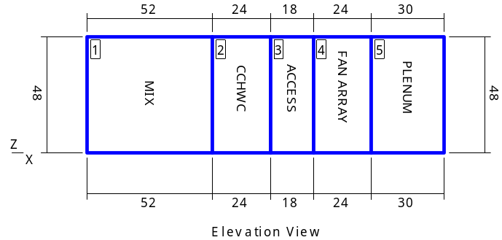 |  |  |  |  | 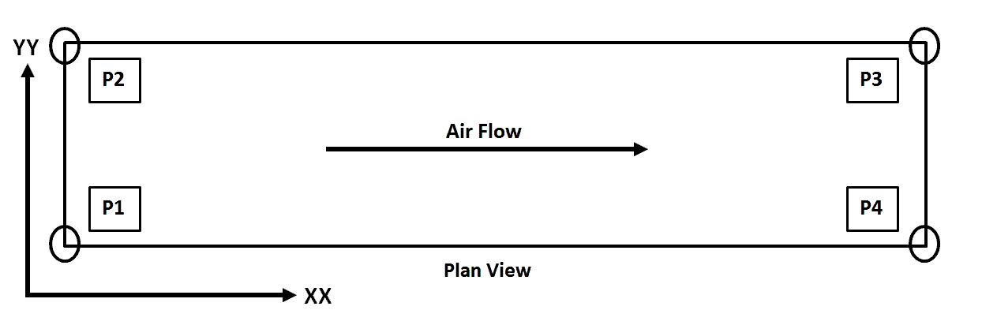
NOTE: Special components aren't included in the corner weights and center of gravity data.
NOTE: Shipping weights listed do not include weight of water (listed in coil section(s) above.

Shipping Protection | None

Supply Static Pressure Drop
Component | Option | Static Pressure Drop
Mixing Box | Filter | 0.54 insWg
Mixing Box | Mixing Box | 0.09 insWg
Combination Coil | Chilled Water Coil | 0.72 insWg
Combination Coil | Reheat Water Coil | 0.33 insWg
Access Section | Access Section
Supply Fan | Cabinet
Plenum Section | Plenum Section | 0.05 insWg
External Static | External Static | 1.50 insWg
Total Supply Fan Static |  | Total Supply Fan Static | 3.23 insWg

Minimum Recommended Drain Pan Trap Dimensions
Shipping Section | Component |  | H
2 | Combination Coil |  | 3.20
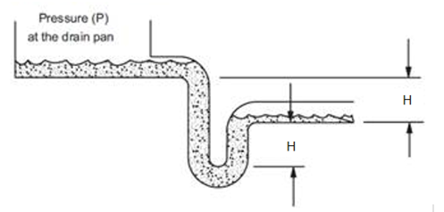
Dimensions provided as a courtesy and are recommended minimums only. Daikin is not responsible for supplying or designing drain pan traps and is not responsible for any damage caused by incorrect trap heights. The dimensions listed above should be reviewed and approved by a licensed plumbing professional.
This calculation is based on an assumption that 0.25 inches of the external static pressure is in the return duct and the remainder is in the supply duct. If actual conditions vary from this assumption then contact Applications for new trap height recommendations.

AHRI Certification
 | Certified by the AHRI Central Station Air-Handling Unit (AHU) Certification Program, which is based on AHRI Standard 430/431. AHRI certified units are subject to rigorous and continuous testing, have performance ratings independently measured and are third-party verified. Certified units may be found in the AHRI Directory at www.ahridirectory.org.

Notes
Standard
1. As a standalone component, unit meets or exceeds requirements of ASHRAE 90.1 - 2007. The approving authority is responsible for compliance of multi - component building systems.

